**Detection Subsystem**

The main aim of the detection subsystem is to create a field vision for the teleoperator. Since this subsystem is the only source of information for the teleoperator, it must gather all the important data around the robot. This system must gather lots of visual data with minimum delay.

**Solution and Relevant Algorithms**

**Plan A**

To design most suitable solution for detection unit, we decided to use a on board camera attached to the robot. Since the video data contains most of the valuable information the teleoperator needs, we decided to use an onboard camera for visual input. After obtaining the video input from the camera, the current frame of video is directly transferred to the telecontroller subsystem by communication subsystem without any processing.

Due to the competitive nature of this project, the delay between teleoperator and visual of playfield must be as short as possible. To decrease delay time caused by detection subsystem, we directly send the raw video data without any processing.

In this submodule we decided to use AKK KC03 800TVL NTSC Switchable Camera Module, shown in figure 1, since it has a built-in transmitter, which we are going to use in communication subsystem. This camera module provides high quality video output for the telecontroller.

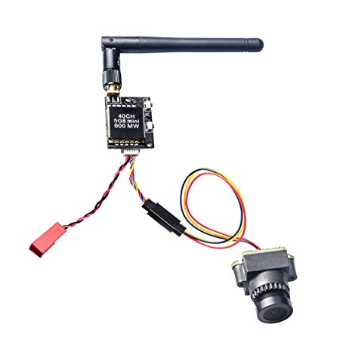

Figure 1: AKK KC03 800TVL NTSC Switchable Camera Module 600mW FPV Transmitter [1]

**Plan B**

Despite being able to provide all the necessary information to the teleoperator, the directly sending raw data to teleoperator will cause some problems. In case of any problem, as a backup plan we have option to process the raw video data and send the processed data to the telecontroller. In this approach we need to develop an image processing algorithm which extracts all the necessary information from the raw image. The information retrieved from the frame is sent to telecontroller. In the telecontroller, the reduced image data is rebuilt to create a meaningful visual data

To obtain visuals of the playfield, the raspberry pi camera module, can be observed in in figure 2, is the best available option, due to its compatibility with development board. The detailed information on development boards, which will be used in this case, is provided in main processor subsystem.

The working principle of this subsystem is, the camera takes current frame from the playfield and sends the data to processor. In the processor an image processor algorithm runs and obtains necessary information’s from this frame. The necessary information is the location of ball, opponents goal, robot’s location and midlines location. After obtaining this data, it transfers this data to telecontroller via communication subsystem.

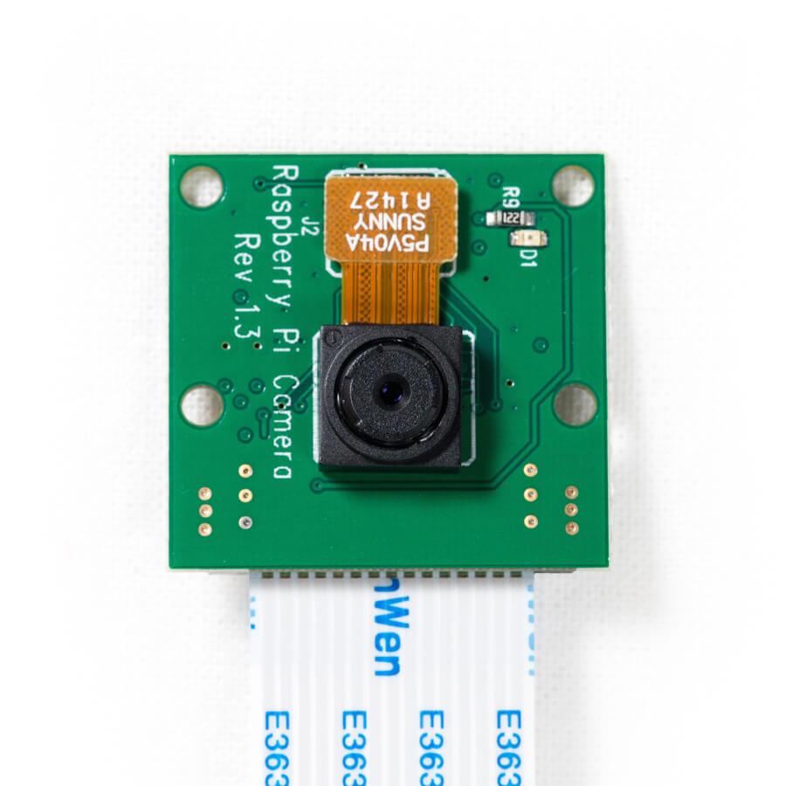

Figure 2: Raspberry Pi Camera module [2]

**Plan C**

Instead of being a backup plan, this plan is an enhancement plan for the plan A and B. Since the visual angle of camera is limited, it is impossible to obtain full field vision with a camera. Hence, to extent the vision of telecontroller a network of sensors will be added to the robot. The sensors are located in the blind spots of the camera and collect basic information from these regions. With the help of this sensor network, the vision of teleoperator will enhance.

When building sensor network two sensor option we consider two types of sensors, infrared proximity sensors and ultrasonic sensors. These sensors can be observed in figure 3 and figure 4 respectively.

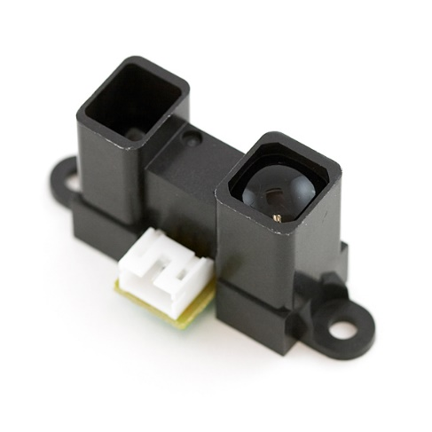

Figure 3: IR proximity sensor [3]

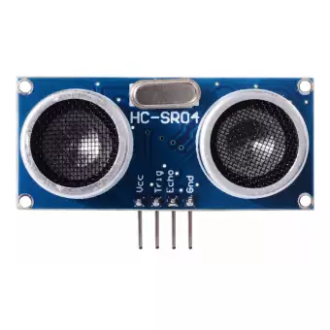

Figure 4: Ultrasonic sensor [4]

**Level Risk Assessment**

There are few risks of using the above-mentioned approaches. These risks are stated below

* In prebuilt system, all the elements are embedded into one module. In case of any problem or performance issue, it is very hard to implement any modifications.
* Due to high volume of data systems must work on very high frequency. This will cause overheating and if no precautions will be taken this seriously harm the robot.
* The precision of sensors are not stable, show variations in every run. In the development of the algorithm this must be considered.

**Error Sources**

Some internal and external sources will harm the operation of this subsystem. These sources are shown below

* The precision of detection systems heavily depends on environmental conditions such as heat, illumination, material of detected object etc.
* Voltage spikes in the power source will seriously harm voltage sensitive components. These sensors must be isolated from the rest of the robot.
* Cameras and sensors are sensitive components hence any hit on them will create irreversible damage on them. These components must be protected from any hit.

**Test Results**

After we connect the detection subsystem to the system, we run several test on the detection module to measure the quality and stability of sent data. To test the necessary qualities of the camera, we run the color visibility test under different environment.

For the test, we built a test setup which consist of our camera module, transmitter, receiver and screen. We sent obtained camera data to the receiver and visually examine from the connected screen, which we are going to use in telecontroller. To determine visibility of colors we show a color scale half meter across to camera and visually examine this scale from the screen. To determine the effect of different ambient light, we run the test on capstone lab and Culture and convention center. To determine the effect of illumination level, in the test locations we run the test on shadow (low level), on well-lit area(mid-level) and under direct light (high-level). In the figure 5 our test results are shown.

Figure 5:Graph of visibility of colors under different environment light for our camera

**Comparative analysis**

To have a better grasp on the proposed solutions, we have compared the properties of both system. The comparison can be observed in table 1.

Table 1: Comparison of main and backup plan

|  |  |  |
| --- | --- | --- |
|  | Main Plan Direct video data transfer | Backup Plan Reduced video data transfer |
| Data Size | 900kByte per frame | 10kByte per frame |
| Processıng Time | None | 0.1 sec |
| Data precison on Telecontroller | Original image | Rebuilt image |
| Price | 10$ | 50$ |
| Stability | High | Mediocre |
| Modifications | N/A | Available |
| Adaptibility | N/A | Yes |

As observed from the table our main plan is superior to backup plan in the most important fields. I can provide high quality data with no processing time. Moreover, it is inexpensive and more stable than its counterparts. On the other hand, the main limitation we faced in this plan is the unavailability of any modifications on the prebuilt module. In case of any problem, we are not able to modify the system. In this condition our backup plans comes into consideration, since all aspects of this plan is open to modification.

REFERNCES

[1] AKK KC03. 800TVL FPV Camera with 600MW Transmitter (n.d.). Retrieved from <https://www.akktek.com/akk-kc03.html>

[2] Raspberry Pi Camera. (n.d.). Retrieved from <https://www.dexterindustries.com/shop/raspberry-pi-camera>

[3] Infrared Proximity Sensor Long Range - Sharp GP2Y0A02YK0F. (n.d.). Retrieved from <https://www.sparkfun.com/products/8958>

[4] Ultrasonic Sensor HC-SR04. (n.d.). Retrieved from <https://www.lazada.com.ph/products/ultrasonic-sensor-hc-sr04-i102973276-s103282735.html>